How to Change WIFI Name and Password
1. Login the management page. The method showed below.
How to login PLC management page.docx
2.In the wireless settings part, you can configure the WiFi name and password manually, and specify the time that you want to enable/disable your WiFi.( The password length can be set from 8 to 63 bits)

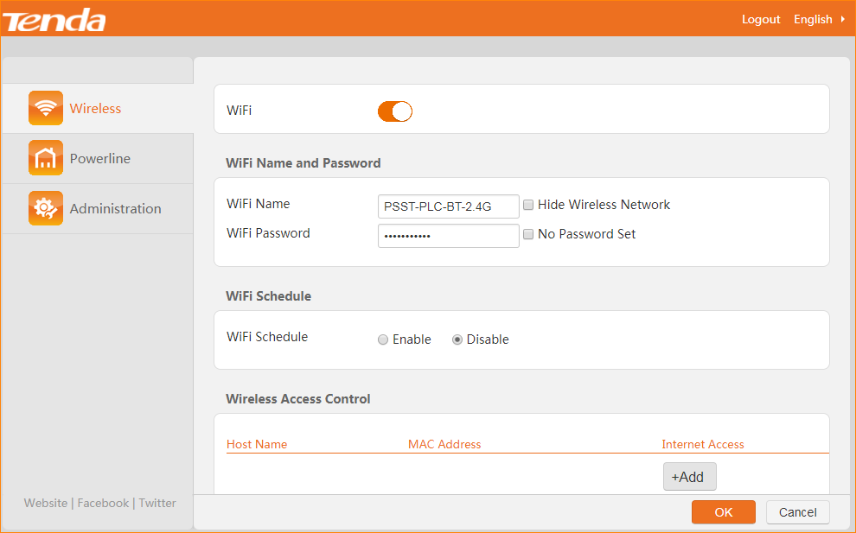
2. Click OK on the bottom of this page to apply your settings.

